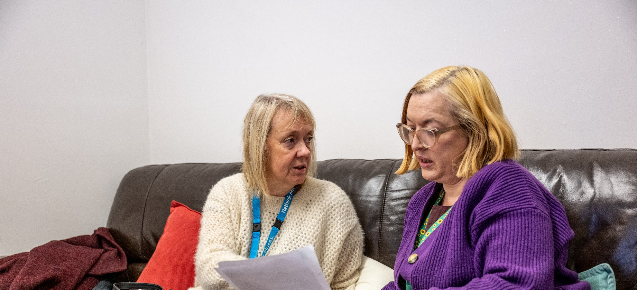

Self-referral Form
Bristol Community Service
Kindly note: You must live within Bristol City Council borough limits. This means BS1 to BS16.
Unfortunately, we do not cover the Bristol borough areas which are covered by the Local
Authorities of South Gloucestershire or Bath and North East Somerset.

We will get in touch when we have reviewed the form to let you know the services we provide in
more detail. If you have any questions, we can answer these and you can tell us whether you
are happy to be added to the waiting list. If based on the form, we cannot accept your referral.
We will let you know the reasons why we must decline your referral.

Please complete the self-referral form and return it by email to: bristolservices@rethink.org
Or phone us on 0117 903 1805, and leave a message, with your name and phone number. We will be happy to complete the self-referral form with you over the phone. This shouldn’t take longer than 45 minutes.
Unfortunately, we do not have a postal address to return the form to.
- Referee Details
Forenames: |  |  |  |  | Click here to enter text. |  |  |  |  |  |  |  | Referral Date: |  |  | Add date
Surname: |  |  |  |  | Click here to enter text. |  |  |  |  | Date of Birth: |  |  |  | dd/mm/yyyy
Title: |  |  |  |  | ☐ Mr ☐ Miss ☐ Mrs ☐ Ms ☐ Other Click here to enter text
Marital Status |  |  |  |  | ☐ Single ☐ Married ☐ Divorced  ☐ Widowed ☐ Separated ☐ Civil partnership  ☐ Dissolved civil partners ☐ Surviving partner from a civil partnership  ☐ Co-habiting ☐ Prefer not to say
Gender: |  |  |  | ☐ Female ☐ Male ☐ Non-Binary ☐ Gender fluid ☐ Other ☐ Prefer not to say
Gender same as sex assigned at birth: |  |  |  |  |  |  | ☐ Yes ☐ No ☐ Prefer not to say
Preferred pronouns: |  |  |  |  |  | ☐ He / Him ☐ She / Her ☐ They / Them  ☐ Other Click here to enter text ☐ Prefer not to say
Phone number(s): |  |  | Click here to enter text. |  |  |  |  |  | Email: |  | Click here to enter text
Preferred method of contact: |  |  |  |  |  |  |  | ☐ Text ☐ Phone ☐ Email
Do you require an interpreter? |  |  |  |  |  |  |  | ☐ Yes ☐ No
Language needs |  |  |  |  |  |  |  | If an interpreter is required, please state preferred language.  Language: Click here to enter text.
Address: |  | Click here to enter text. |  |  |  |  |  |  |  |  |  | Postcode: |  |  | Add postcode
Sexual orientation: |  |  |  | ☐ Asexual ☐ Bisexual ☐ Gay ☐ Heterosexual  ☐ Lesbian ☐ Pansexual ☐ Queer ☐ Questioning ☐ Other ☐ Prefer not to say
Ethnicity: | Asian/Asian British: ☐ Bangladesh ☐ Chinese ☐ Indian ☐ Pakistani ☐ Other  Black/Black British: ☐ African ☐ Caribbean ☐ Other  Mixed: ☐ White Asian ☐ White & Black African  ☐ White & Black Caribbean ☐ Other  White: ☐ British ☐ Irish ☐ Gypsy or Irish Traveller  ☐ Roma ☐ Other  Additional: ☐ Arab ☐ Other Ethnic Group ☐ Prefer not to say  If Other, please specify Click here to enter text.
Religion: | Your religion: Click here to enter text. ☐ No religion ☐ Prefer not to say
Accommodation Status: |  |  |  |  |  | ☐ Council Tenant ☐ Homeless or No fixed Abode ☐ Temporary Accommodation ☐ Housing Association  ☐ Private Landlord ☐ Independent Accommodation  ☐ Independent Accommodation with support  ☐ Living with Family or Friends ☐ Owning  ☐ Registered Care Home ☐ Supported Accommodation
Employment Status: |  |  |  |  |  | ☐ Full-time education ☐ Part-time education  ☐ Non-paid employment ☐ Not in employment, education or training ☐ Retired ☐ Working full-time  ☐ Working part-time ☐ Prefer not to say
Support Needs: |  |  |  |  |  | Deaf / Hearing Loss ☐ Yes ☐ No Details: Click here to enter text.  Blind / Partially Sighted ☐ Yes ☐ No Details: Click here to enter text.  Speech / communication Difference  ☐ Yes ☐ No Details: Click here to enter text.  Able to Read ☐ Yes ☐ No Details: Click here to enter text.  Able to use the Internet ☐ Yes ☐ No Details: Click here to enter text.  Learning Disability ☐ Yes ☐ No Details: Click here to enter text.  Neurodivergent ☐ Yes ☐ No Details: Click here to enter text.  Sensory Disability ☐ Yes ☐ No Details: Click here to enter text.  Physical Disability ☐ Yes ☐ No Details: Click here to enter text.  Currently Pregnant ☐ Yes ☐ No Details: Click here to enter text.  Other support needs Details: Click here to enter text.

- Your mental health
Formal diagnosis (if applicable): | Click here to enter text
How does your mental health affect your everyday life: |  | Click here to enter text

- Reason for referral
Click here to enter text

- Risk
Harm to self: | Click here to enter text
Harm from others: |  |  | Click here to enter text
Harm to others: |  | Click here to enter text

- Dependants
Dependants: | ☐Yes ☐No
If yes, please specify: |  | Click or tap here to enter text.

Please be aware of our Personal Data Protection Policy by visiting our website, https://www.rethink.org/ where you can find a copy of the leaflet on how we protect your data. Alternatively, call us on 0117 903 1805
Rethink Mental Illness, a company limited by guarantee. Registered in England Number 1227970. Registered Charity Number 271028. Registered Office 28 Albert Embankment, London, SE1 7GR. Authorised and regulated by the Financial Conduct Authority (Firm Registration Number 624502). © Rethink Mental Illness 2023.
Rethink Mental Illness, a company limited by guarantee. Registered in England Number 1227970. Registered Charity Number 271028. Registered Office 28 Albert Embankment, London, SE1 7GR. Authorised and regulated by the Financial Conduct Authority (Firm Registration Number 624502). © Rethink Mental Illness 2023

