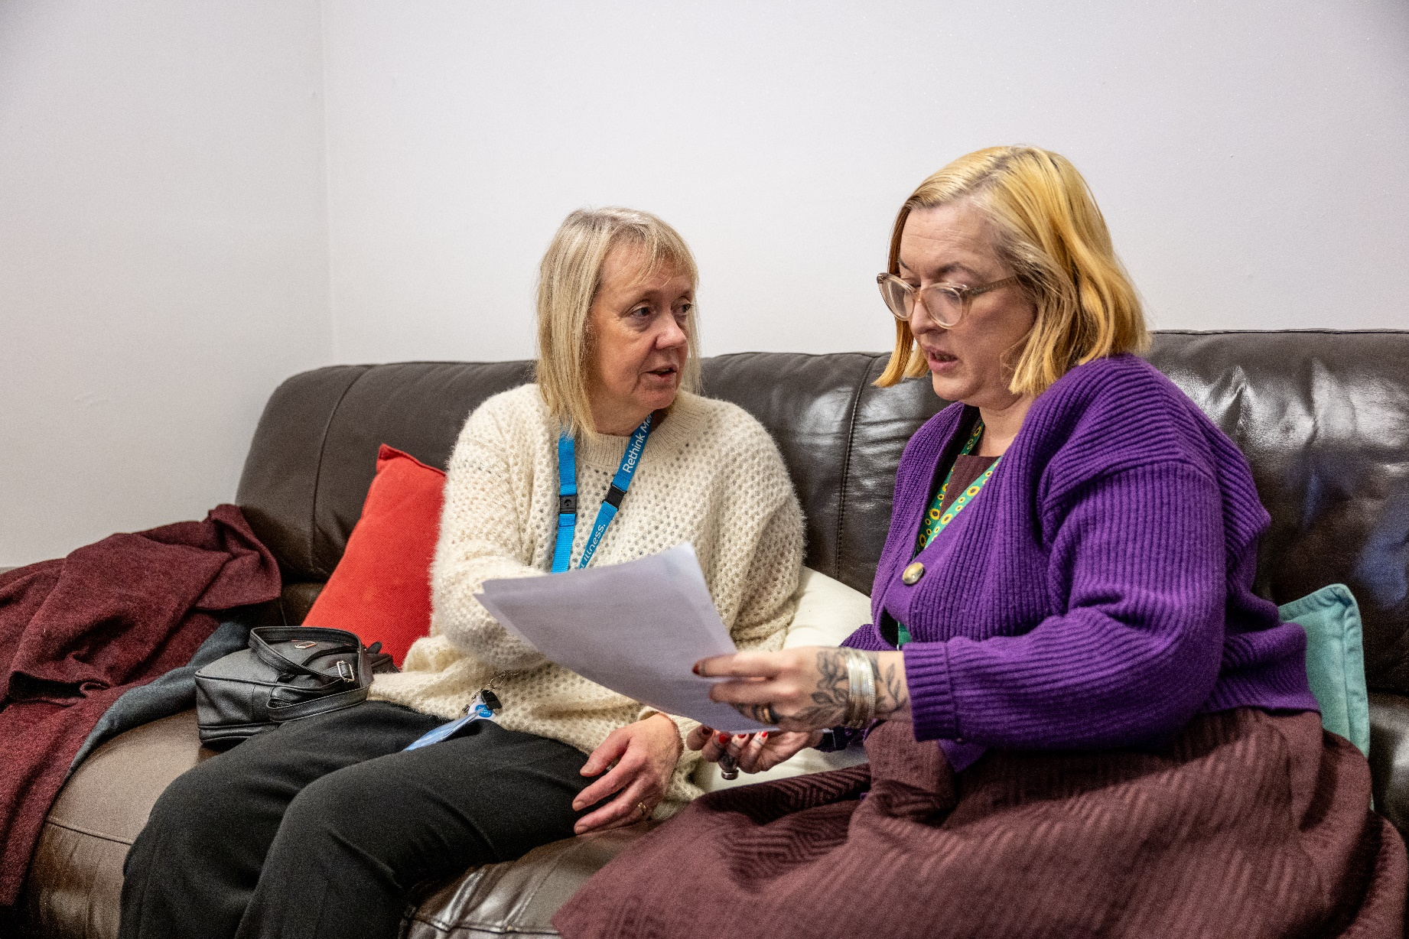

**Self-referral Form**

**Bristol Community Service**



**Kindly note:** Referees must live within Bristol City Council, unfortunately we do not cover   
South Gloucestershire or BANES.

We will make contact directly with the referee, the form should be completed with their involvement and agreement.

**Once completed please return to:** [**bristolservices@rethink.org**](mailto:bristolservices@rethink.org)

**or post to:** Rethink Mental Illness, Docklands Community Centre, First Floor, 29 Brigstocke Road, Bristol, BS2 8UA

1. **Referee Details**

|  |  |  |  |  |  |  |  |  |  |  |  |  |  |  |  |  |
| --- | --- | --- | --- | --- | --- | --- | --- | --- | --- | --- | --- | --- | --- | --- | --- | --- |
| **Forenames:** | | | | Click or tap here to enter text. | | | | | | | | | **Referral Date:** | | | Add date |
| **Surname:** | | | | Click or tap here to enter text. | | | | | | | **Date of Birth:** | | | Add date | | |
| **Gender:** | Female Male Non-Binary Gender fluid Other Prefer not to say | | | | | | | | | | | | | | | |
| **Preferred pronouns:** | | | | | | | He/him She/her They/them Other Prefer not to say | | | | | | | | | |
| **Phone number(s):** | | | | | Click here to enter text. | | | | | **Email:** | | Click or tap here to enter text. | | | | |
| **Preferred method of contact:** | | | | | | | | | Text Phone Email | | | | | | | |
| **Address:** | | | Click or tap here to enter text. | | | | | | | | | | **Postcode:** | | Add postcode. | |
| **Sexual orientation:** | | | | | | Asexual Bisexual Don’t know Heterosexual Gay  Lesbian Pansexual Other Prefer not to say | | | | | | | | | | |
| **Ethnicity:** | | **Asian/Asian British:** Bangladesh Chinese Indian Pakistani Other  **Black/Black British:** African Caribbean Other  **Mixed:** White Asian White and Black African White and Black Caribbean   Other  **White:** British Irish Other  **Additional:** Arab Other Ethnic Group Prefer not to say | | | | | | | | | | | | | | |
| **Religion:** | | Your religion:Click or tap here to enter text.No religionPrefer not to say | | | | | | | | | | | | | | |
| **Name of GP Surgery:** | | | | | | | | Click or tap here to enter text. | | | | | | | | |
| **Emergency contact** | | | | | | | | Click or tap here to enter text. | | | | | | | | |

1. **Next of kin or professional involved**

|  |  |  |  |  |  |  |  |  |
| --- | --- | --- | --- | --- | --- | --- | --- | --- |
| **Name:** | Click or tap here to enter text. | | | | | | **Referral Date:** | Add date |
| **Organisation / service** | | Click or tap here to enter text. | | **Job role:** | | Click or tap here to enter text. | | |
| **Phone number:** | | Click here to enter text. | **Email:** | | Click or tap here to enter text. | | | |

1. **Your mental health**

|  |  |  |
| --- | --- | --- |
| **Formal diagnosis (if applicable):** | Click or tap here to enter text. | |
| **Source of diagnosis:** | | Click or tap here to enter text. |
| **How does your mental health affect your everyday life:** | | Click or tap here to enter text. |

1. **Reason for referral**

|  |
| --- |
| Click or tap here to enter text. |

1. **Risk**

|  |  |  |  |
| --- | --- | --- | --- |
| **Harm to self:** | Click or tap here to enter text. | | |
| **Harm from others:** | | | Click or tap here to enter text. |
| **Harm to others:** | | Click or tap here to enter text. | |

1. **Dependants**

|  |  |  |
| --- | --- | --- |
| **Dependants:** | Yes No | |
| **If yes, please specify:** | | Click or tap here to enter text. |

1. **Additional Information**

|  |  |  |
| --- | --- | --- |
| **Language needs:** | If an interpreter is required, please state language(s) and gender preference:  Male  Female Either | |
| **Other needs or disabilities:** | | Click or tap here to enter text. |
| **Any children in the household?** | | Click or tap here to enter text. |

Please be aware of our Personal Data Protection Policy by visiting our [website,](https://www.rethink.org/help-in-your-area/services/community-support/bristol-community-support-services/) **https://www.rethink.org/** where you can find a copy of the leaflet on how we protect your data. Alternatively, call us on[**0117 903 1805**](tel:0117%20903%201805)

Rethink Mental Illness, a company limited by guarantee. Registered in England Number 1227970. Registered Charity Number 271028. Registered Office 28 Albert Embankment, London, SE1 7GR. Authorised and regulated by the Financial Conduct Authority (Firm Registration Number 624502). © Rethink Mental Illness 2023.