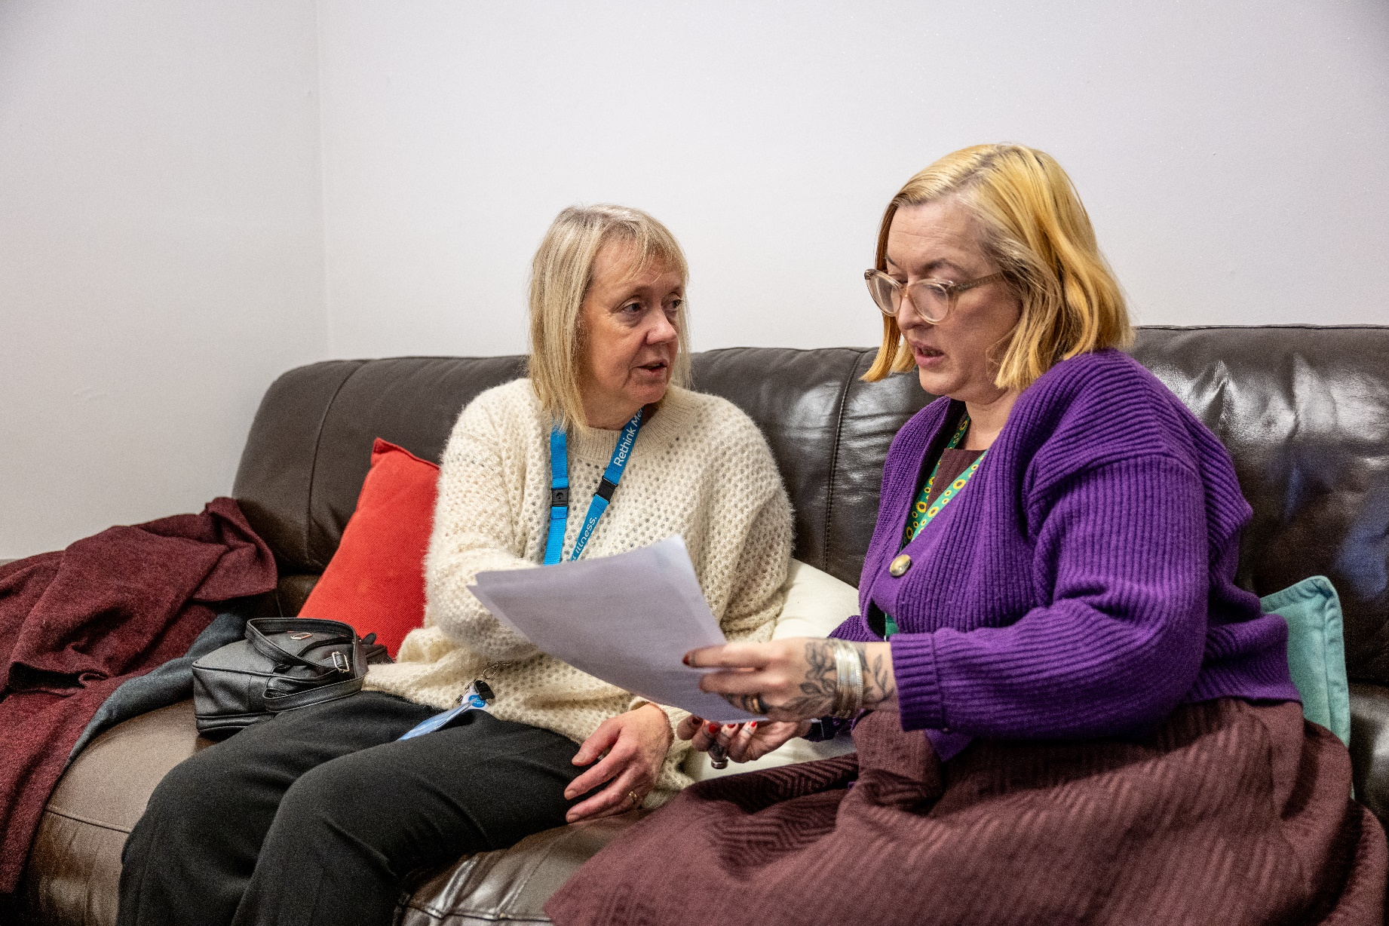

**Self-referral Form**

**Bristol Community Service**



**Kindly note:** Referees must live within Bristol City Council, unfortunately we do not cover South Gloucestershire or BANES.

We will make contact directly with the referee, the form should be completed with their involvement and agreement.

**Once completed please return to:** [**bristolservices@rethink.org**](mailto:bristolservices@rethink.org)

**or post to:** Rethink Mental Illness, Docklands Community Centre, First Floor, 29 Brigstocke Road, Bristol, BS2 8UA

1. **Referee Details**

|  |  |  |  |  |  |  |  |  |  |  |  |  |  |  |  |  |
| --- | --- | --- | --- | --- | --- | --- | --- | --- | --- | --- | --- | --- | --- | --- | --- | --- |
| **Forenames:** | | | |  | | | | | | | | | **Referral Date:** | | |  |
| **Surname:** | | | |  | | | | | | | **Date of Birth:** | | |  | | |
| **Gender:** | Female Male Non-Binary Gender fluid Other Prefer not to say | | | | | | | | | | | | | | | |
| **Preferred pronouns:** | | | | | | | He/him She/her They/them Other Prefer not to say | | | | | | | | | |
| **Phone number(s):** | | | | | 07521 747052 | | | | | **Email:** | |  | | | | |
| **Preferred method of contact:** | | | | | | | | | Text Phone Email | | | | | | | |
| **Address:** | | |  | | | | | | | | | | **Postcode:** | |  | |
| **Sexual orientation:** | | | | | | Asexual Bisexual Don’t know Heterosexual Gay  Lesbian Pansexual Other Prefer not to say | | | | | | | | | | |
| **Ethnicity:** | | **Asian/Asian British:** Bangladesh Chinese Indian Pakistani Other  **Black/Black British:** African Caribbean Other  **Mixed:** White Asian White and Black African White and Black Caribbean   Other  **White:** British Irish Other  **Additional:** Arab Other Ethnic Group Prefer not to say | | | | | | | | | | | | | | |
| **Name of GP Surgery:** | | | | | | | |  | | | | | | | | |
| **Emergency Contact** | | | | | | | |  | | | | | | | | |

1. **Next of kin or professional involved**

|  |  |  |  |  |  |  |  |  |
| --- | --- | --- | --- | --- | --- | --- | --- | --- |
| **Name:** |  | | | | | | **Referral Date:** |  |
| **Organization/service** | |  | | **Job role:** | |  | | |
| **Phone number:** | |  | **Email:** | |  | | | |

1. **Your mental health**

|  |  |  |
| --- | --- | --- |
| **Formal diagnosis (if applicable):** |  | |
| **Source of diagnosis:** | |  |
| **How does your mental health affect your everyday life:** | |  |

1. **Reason for referral**

|  |
| --- |
|  |

1. **Risk**

|  |  |  |  |
| --- | --- | --- | --- |
| **Harm to self:** |  | | |
| **Harm from others:** | | |  |
| **Harm to others:** | |  | |

1. **Dependants**

|  |  |  |
| --- | --- | --- |
| **Dependants:** | Yes No | |
| **If yes, please specify:** | |  |

1. **Additional Information**

|  |  |  |
| --- | --- | --- |
| **Language needs:** | If an interpreter is required, please state language(s) and gender preference:  Male  Female Either | |
| **Other needs or disabilities:** | |  |
| **Any children in the household?** | |  |

1. **Support Agreement:** To know how we can help you, the allocated Recovery Coach will complete with you a support plan. This will identify the strengths you want to work on and together you will agree on how best to succeed.

Please note that if you miss two consecutive appointments you will be sent a letter giving you 14 days to get in touch. If you do not get in touch, we will assume that things are going well and that you no longer require support. If you need to cancel an appointment please inform your recovery coach as early as possible, at the latest by 9:30 am on the day of the appointment.

Please tick the below to let us know if you wish to accept our support agreement.

|  |
| --- |
| Yes No |

1. **Online Support:** You can access free, online resources by signing up for Clic, Bristol. Our team of dedicated moderators ensures a secure and respectful environment by actively monitoring the community from 8 am to 10 pm, 7 days a week.

CLIC, Bristol requires a one-time sign-up to ensure confidentiality, allowing individuals to use the platform with an anonymous name if preferred. We prioritize user privacy and maintain strict confidentiality of all sign-up information.

Key features include:

* Clic Community Chat
* Discussion Forums
* Information & Support
* Mood Tracker

Thank you for considering CLIC, Bristol as a valuable resource in supporting mental health within your organization. Together, we can positively impact and foster a community that thrives on well-being.

Sign up: <https://bristol.clic-uk.org>

Please be aware of our Personal Data Protection Policy by visiting our [**website,**](https://www.rethink.org/help-in-your-area/services/community-support/bristol-community-support-services/)https://www.rethink.org/ where you can find a copy of the leaflet on how we protect your data. Alternatively, call us on[**0117 903 1805**](tel:0117%20903%201805)

Rethink Mental Illness, a company limited by guarantee. Registered in England Number 1227970. Registered Charity Number 271028. Registered Office 28 Albert Embankment, London, SE1 7GR. Authorised and regulated by the Financial Conduct Authority (Firm Registration Number 624502). © Rethink Mental Illness 2023.